National Arts & Humanities Month 2022 Communications Toolkit

On the web: www.AmericansForTheArts.org/NAHM

On Social Media: Use #NAHM, #ShowYourArt2022

Americans for the Arts on social media
Twitter: @americans4arts, https://twitter.com/americans4arts
Facebook: https://www.facebook.com/americans4arts/
Instagram: @americans4arts, https://www.instagram.com/americans4arts/

The following sample posts are provided for your convenience, and to promote consistent messaging about National Arts & Humanities Month across social media. Feel free to tweak language to fit your/your organization’s voice or customize the text to best reflect your goals and plans for NAHM!

We encourage you to send followers to your website so they can learn more about your organization and/or any specific celebrations you are planning for NAHM in your community. Alternately, you may feel free to include a link to the National Arts & Humanities Month section of the Americans for the Arts website.

You may use National Arts & Humanities Month logos with your social media posts and in your newsletters—visit the NAHM Resources web page to download files and a branding guide. Shareable graphics for #ShowYourArt2022 are available for download on the Show Your Art page. Please consider using alt text when posting images—information and suggested alt text is provided below the following sample posts.

General Messaging

To Use Before NAHM (through Sept. 30)

Twitter

October is National Arts & Humanities Month! The arts and humanities are an important part of our lives every day and make [YOUR COMMUNITY] healthier and stronger. Learn more at [YOUR WEBSITE]. #NAHM

The arts and humanities connect cultures, promote well-being, address inequities, and make [YOUR COMMUNITY] healthier and stronger. Celebrate National Arts & Humanities Month with us this October! Learn more at [YOUR WEBSITE].

Facebook/LinkedIn/Instagram

October is National Arts & Humanities Month! The arts and humanities are an important part of our lives every day. They connect cultures, promote well-being, address inequities, and make [YOUR COMMUNITY] healthier and stronger in so many ways. Celebrate National Arts & Humanities Month with us this October! [Include details of your celebrations if desired] Learn more at [YOUR WEBSITE].

Newsletter

Did you know October is National Arts & Humanities Month? It’s a month-long recognition of the importance of culture in America, and [YOUR ORGANIZATION] is excited to celebrate with you! The arts and humanities are an important part of our lives every day—they connect cultures, promote well-being, address inequities, and make [YOUR COMMUNITY] healthier and stronger in so many ways. [Include details of your celebrations if desired] Learn more about how you can participate at [YOUR WEBSITE].

To Use During NAHM (October 1-31)

Twitter

Happy National Arts & Humanities Month! We’re celebrating culture all October long and want to hear from you: what do you love about the arts and humanities in [YOUR COMMUNITY]? #NAHM

It’s National Arts & Humanities Month! We’re celebrating the power and impact of culture in [YOUR COMMUNITY] to connect us, promote health and well-being, address inequities, and create a stronger community for everyone. How will you celebrate this month? #NAHM

Facebook/LinkedIn/Instagram

October is National Arts & Humanities Month! We’re celebrating the power and impact of culture to connect us, promote health and well-being, address inequities, and create a stronger community for everyone. We want to hear from you: what do you love about the arts and humanities in [YOUR COMMUNITY]? And how will you celebrate this month? #NAHM

Newsletter

October is National Arts & Humanities Month! We’re celebrating the power and impact of culture in [YOUR COMMUNITY] to connect us, promote health and well-being, address inequities, and create a stronger community for everyone—and we hope you’ll join us. [Include details of your celebrations and links to events or other relevant information]

Instagram Challenge #ShowYourArt2022

Social media

This October, let’s flood social media with culture! Celebrate National Arts & Humanities Month with #ShowYourArt2022, a daily theme challenge to inspire your creative spirit and showcase the culture that makes [YOUR COMMUNITY] unique and vibrant. You can even invite your friends to join in the fun! And whether you post once or all month long, you’ll be part of the movement showing the power and purpose of the arts and humanities across all parts of life. [optional final sentence:] Be sure to tag us in your posts so we can reshare the culture you love in our community! #NAHM #ShowYourArt2022

Newsletter

Celebrate National Arts & Humanities Month with #ShowYourArt2022, an Instagram challenge that will inspire your creative spirit and showcase the culture that makes [YOUR COMMUNITY] unique and vibrant. You can even invite your friends to join in the fun! And whether you post once or all month long, you’ll be part of the movement showing the power and purpose of the arts and humanities across all parts of life. See the daily themes and download shareable social media graphics at https://www.americansforthearts.org/events/national-arts-and-humanities-month/show-your-art.

Alt Text

We encourage you to include alt text on media in social media posts about National Arts & Humanities Month and the poster competition. Alt text provides visual description of images via screen readers for users with visual impairments. Many social networks now allow you to add alt text directly to an image when posting, or you can include alt text at the end of your post. Social media strategist Alexa Heinrich is a great resource on how to use alt text on social media.

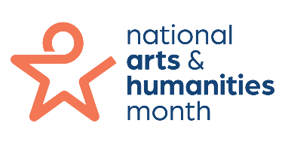
Suggested alt text (all logo versions):
National Arts & Humanities Month logo, with an orange rounded star icon and stacked text in blue.

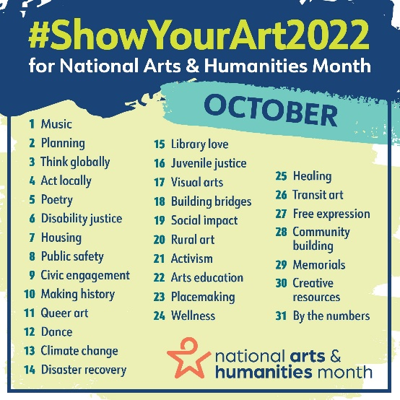
Suggested alt text:
Colorful graphic showing the daily list of themes for Show Your Art 2022, National Arts and Humanities Month.
Note: we recommend including the full list of themes for those using screen readers in either the alt text or the body of your social post. Download a text list of themes here.

