Arts Facts . . . NEA Funding Fails to Keep Pace with Inflation
The NEA budget has long failed to keep pace with inflation and its share of federal non-defense discretionary spending. When adjusted for inflation, the NEA’s 1992 budget is twice the actual 2020 budget.

If the National Endowment for the Arts (NEA) had simply maintained its 1984 percentage of non-defense discretionary spending (11 cents per $100 of spending), the 2020 NEA budget would be $693.2 million instead of $162.25 million.
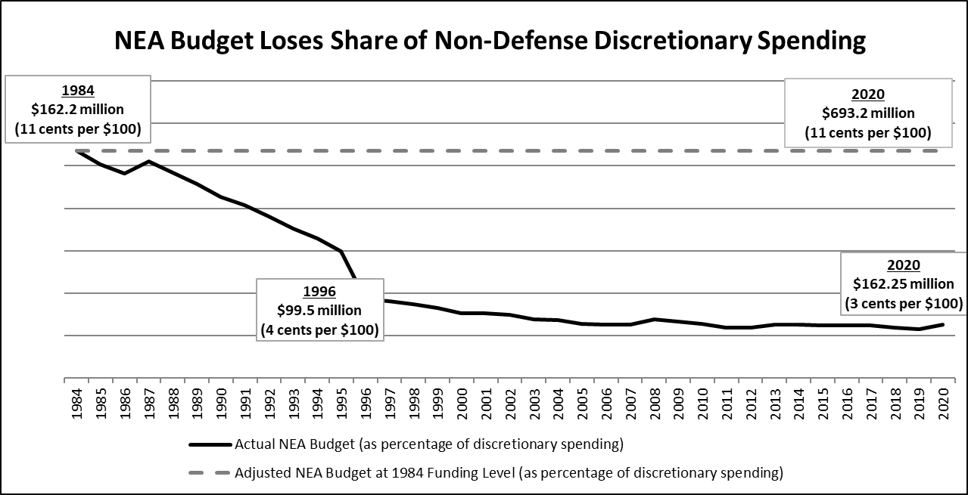

If the NEA's 1992 budget had simply remained constant and was only adjusted for inflation, it would have been $326 million in 2020, instead of $162.25 million, a $164 million difference.

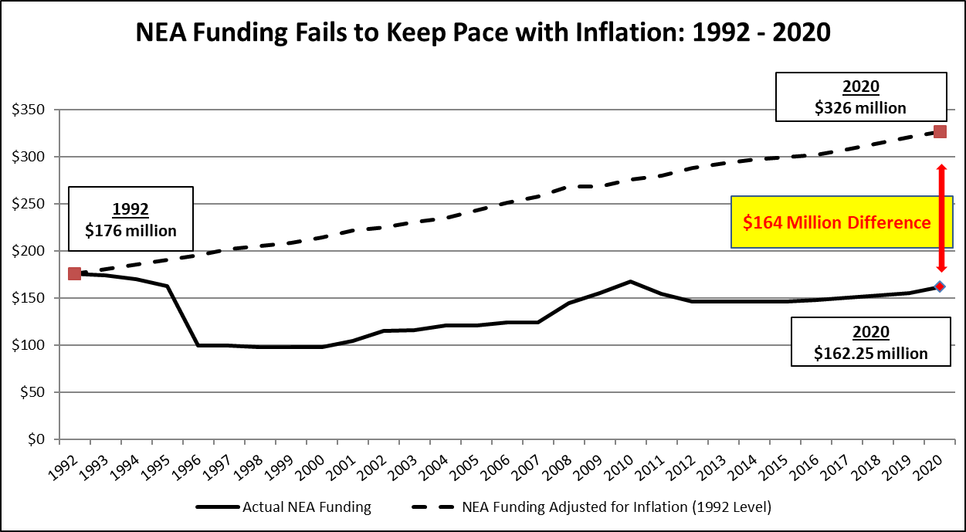

Source: NEA; Congressional Budget Office. Analysis by Americans for the Arts, 2021.

