# Arts Facts . . . Arts Organization Revenues

Revenue from earned income is the largest source of income for nonprofit arts organizations. The remainder must be raised through contributions and grants. Even small fluctuations in contributed revenue can mean deficits for many organizations.

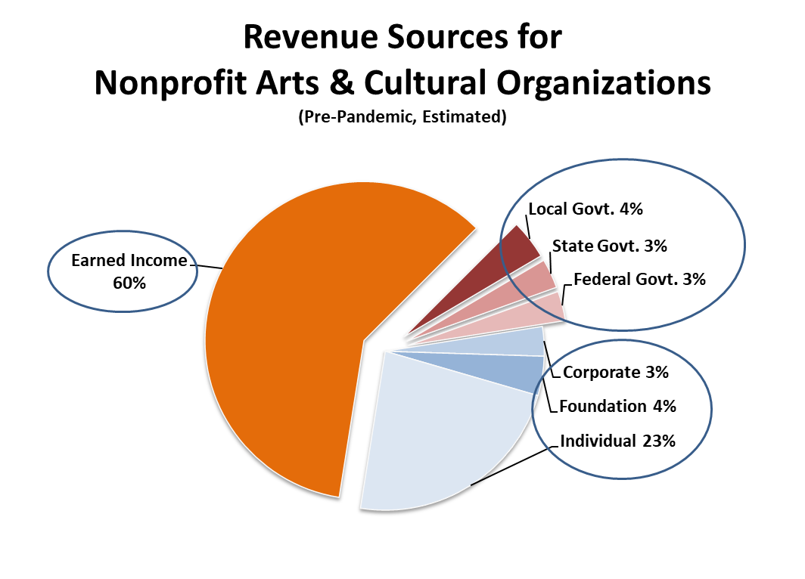

Support for the nonprofit arts is a mosaic of funding sources—a delicate 60-30-10 balance of earned revenue, private sector contributions, and government support. The chart above provides a snapshot of the revenue picture for a typical nonprofit arts and cultural organization in the U.S. Considering that there are approximately 120,000 such organizations, including public sector ones, the revenue picture for individual organizations can vary widely. These estimates are pre-COVID19 pandemic.

1. Earned income (60%) represents a little over half of the total revenue pie and includes ticket sales, sponsorships, fundraising events, and investment and endowment income.
2. Private sector (30%) contributions (individual, foundation, and corporate giving) are the second largest portion of the revenue pie. The largest segment is comprised of individuals.
3. Government funding (10%)—local, state, and federal—is the smallest of the three revenue categories, yet is a vital lever in generating private sector contributions. Note that total federal arts support is not limited to the National Endowment for the Arts. It also includes the Kennedy Center, Smithsonian Institution, Corporation for Public Broadcasting, and even arts programming within the agencies such as the U.S. Departments of Justice and Education. Local and state governments have similarly diverse sources of arts funding.

Source: Estimate by Americans for the Arts based on analyses of federal and industry association data. 2020.